**KWoC Project Report-Alchem**

* **Why I participated in KWoC?**

Although i had idea about how git works , but i never worked on a project in git and I always wanted to contribute to open source projects. As soon as i came to know about KWoC, i didn’t choose project just to know new technologies but to work along with other developers to contribute to open source.

* **Choosing a project**

This depends on why one wants to participate in KWoC. I was only interested in contributing to open source so i choose a project developed on technologies i already know. I choose [**ALCHEM DESKTOP**](https://github.com/alchemsynergy/alchem)**,** which is a accounting application for chemists developed in java.

* **Contributing to project**

**1st commit- Added logout option(** [**Github Link**](https://github.com/alchemsynergy/alchem/pull/24) **):**

There was no logout option in application, so i added logout button in the settings drawer.



Changes were made in settings.fxml file to add logout button.

Its functionality is added in settingsdrawercontroller.java file.

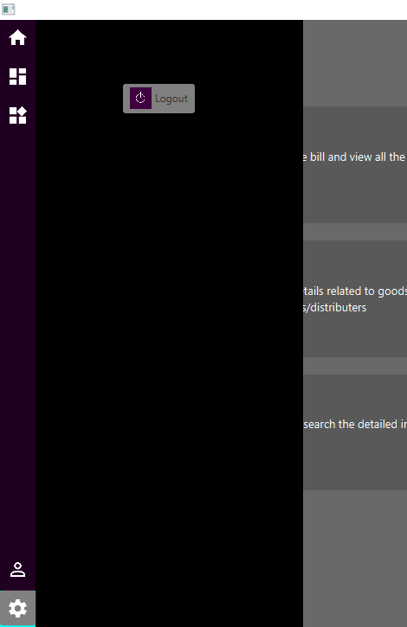

**2nd commit- Addresses the issue in searching in inventory**

**( [Github Link](https://github.com/alchemsynergy/alchem/pull/25) ):**



To remove this issue function called by search field is changed in InventoryController.java file

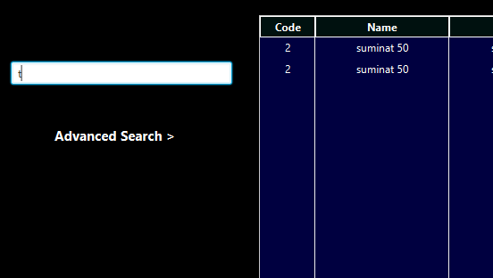

**3rd commit- Changed the functionality of navigation drawer**

**(** [**Github Link**](https://github.com/alchemsynergy/alchem/pull/29) **):**

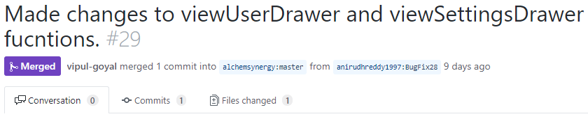

MainStageController.java file is changed to open settings drawer even though user drawer was opened. Before one drawer cannot be opened when other drawer was opened already.